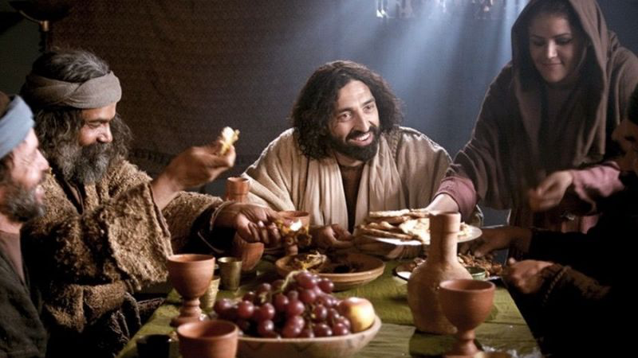  Maundy Thursday  A Shared Meal of Remembrance | WELCOME  You are welcome here. We are all guests at Christ’s table this evening.  St. Andrew’s Presbyterian Church  Newark, Delaware

MAUNDY THURSDAY – A SHARED MEAL OF REMEMBRANCE

CALL TO WORSHIP
ONE: What shall we offer for all God’s goodness to us?
ALL: Let us lift up the cup of salvation and call on the name of the Lord

OPENING PRAYER
Holy God, source and sovereign,
You put all power and authority in the hands of Christ –
Christ, who washes our feet in humble service.
Teach us to love one another as Christ has loved us,
so that everyone will know that we are his disciples.
We pray this in the name of our Teacher and Lord, Jesus. Amen.

CALL TO CONFESSION
The Apostle Paul wrote to the church at Corinth:
Examine yourselves,
and only then eat of the bread and drink of the cup.
For all who eat and drink without discerning the body,
eat and drink judgement against themselves.
If we judged ourselves, we would not be judged.
But when we are judged by the Lord,
We receive discipline so that we may not be condemned along with the world.

EMBODIED CONFESSION – WASHING OF THE HANDS
With confidence in God’s abundant mercy, let us examine and confess our sin silently. As you feel called, and as you are able, please make your ways to one of the hand washing stations. If you are not able to move to a handwashing station, please allow us to wash your hands where you are seated.

Handwashers: Through Christ we are made new again.
Those being washed: Christ have mercy.

As your hands are washed, and as you return to your seats, hold in your hearts the things that separate you from God. Recall the false idols of everyday life. Consider how you might lay those things down, to replace them with a relationship through Christ. Hold silently, in your hearts, the new life offered through Jesus.

ASSURANCE OF PARDON
(John 13:12-17)
“After Jesus had washed the disciples’ feet,
He said to them, “Do you know what I have done to you?
If I, your Lord and Teacher, have washed your feet,
you also ought to wash one another’s feet.
For I have set you an example,
That you also should do as I have done to you.”

Friends, hear and believe the good news of the gospel:
In the name of Jesus Christ, you are forgiven.
Thanks be to God!

A SHARED MEAL
Please share in the fellowship of a communal meal, thankful for God’s abundance.

PRAYER FOR ILLUMINATION
From rough words, God, make something useful. To stubborn ears, bring truth. To tired eyes, bring light. Reveal yourself to your seeking people. We ask in Jesus’ name. Amen.

HEBREW SCRIPTURE READING: Exodus 12:1-14
¹The LORD said to Moses and Aaron in the land of Egypt: ²This month shall mark for you the beginning of months; it shall be the first month of the year for you. ³Tell the whole congregation of Israel that on the tenth of this month they are to take a lamb for each family, a lamb for each household. ⁴If a household is too small for a whole lamb, it shall join its closest neighbor in obtaining one; the lamb shall be divided in proportion to the number of people who eat of it. ⁵Your lamb shall be without blemish, a year-old male; you may take it from the sheep or from the goats. ⁶You shall keep it until the fourteenth day of this month; then the whole assembled congregation of Israel shall slaughter it at twilight. ⁷They shall take some of the blood and put it on the two doorposts and the lintel of the houses in which they eat it. ⁸ They shall eat the lamb that same night; they shall eat it roasted over the fire with unleavened bread and bitter herbs. ⁹Do not eat any of it raw or boiled in water, but roasted over the fire, with its head, legs, and inner organs. ¹⁰You shall let none of it remain until the morning; anything that remains until the morning you shall burn. ¹¹This is how you shall eat it: your loins girded, your sandals on your feet, and your staff in your hand; and you shall eat it hurriedly. It is the passover of the LORD. ¹²For I will pass through the land of Egypt that night, and I will strike down every firstborn in the land of Egypt, both human beings and animals; on all the gods of Egypt I will execute judgments: I am the LORD. ¹³The blood shall be a sign for you on the houses where you live: when I see the blood, I will pass over you, and no plague shall destroy you when I strike the land of Egypt.
¹⁴This day shall be a day of remembrance for you. You shall celebrate it as a festival to the LORD; throughout your generations you shall observe it as a perpetual ordinance.
GOSPEL READING: John 13:1-17, 31b-35¹
Now before the festival of the Passover, Jesus knew that his hour had come to depart from this world and go to the Father. Having loved his own who were in the world, he loved them to the end. ²The devil had already put it into the heart of Judas son of Simon Iscariot to betray him. And during supper ³Jesus, knowing that the Father had given all things into his hands, and that he had come from God and was going to God, ⁴got up from the table, took off his outer robe, and tied a towel around himself. ⁵Then he poured water into a basin and began to wash the disciples’ feet and to wipe them with the towel that was tied around him. ⁶He came to Simon Peter, who said to him, “Lord, are you going to wash my feet?” ⁷Jesus answered, “You do not know now what I am doing, but later you will understand.” ⁸Peter said to him, “You will never wash my feet.” Jesus answered, “Unless I wash you, you have no share with me.” ⁹Simon Peter said to him, “Lord, not my feet only but also my hands and my head!” ¹⁰Jesus said to him, “One who has bathed does not need to wash, except for the feet, but is entirely clean. And you are clean, though not all of you.” ¹¹For he knew who was to betray him; for this reason he said, “Not all of you are clean.”
¹²After he had washed their feet, had put on his robe, and had returned to the table, he said to them, “Do you know what I have done to you? ¹³You call me Teacher and Lord — and you are right, for that is what I am. ¹⁴So if I, your Lord and Teacher, have washed your feet, you also ought to wash one another’s feet. ¹⁵For I have set you an example, that you also should do as I have done to you. ¹⁶Very truly, I tell you, servants are not greater than their master, nor are messengers greater than the one who sent them. ¹⁷If you know these things, you are blessed if you do them.
³¹When he had gone out, Jesus said, “Now the Son of Man has been glorified, and God has been glorified in him. ³²If God has been glorified in him, God will also glorify him in himself and will glorify him at once. ³³Little children, I am with you only a little longer. You will look for me; and as I said to the Jews so now I say to you, ‘Where I am going, you cannot come.’ ³⁴I give you a new commandment, that you love one another. Just as I have loved you, you also should love one another. ³⁵By this everyone will know that you are my disciples, if you have love for one another.”

MEDITATION - Rev. Matt Waters

TITHES AND OFFERINGS
Please leave any offerings as you depart this evening in the plate near the door.

COMMUNION
Please remain at your seat. Communion will be served to you. Please indicate you would like to receive elements by putting your hand out as servers come near.

Jesus said: I am the bread of life.
All who come to me shall not hunger,
and all who believe in me shall not thirst.
With Christians around the world
and throughout the centuries,
we gather around these symbols
of bread and wine—simple elements
that speak of nourishment and transformation.
Let us pray.
Loving God, we thank you
that you are as close to us as breath,
that your love is constant and unfailing.
We thank you for all that sustains life,
and especially for Jesus Christ,
who teaches us how to live out
an ethic of justice and peace,
and for the promise of transformation
made manifest in his life, death and resurrection.
We ask you to bless this bread and this cup.
Through this meal, make us the body of Christ,
that we may join with you in promoting the well-being of all creation. Amen.
We remember on the night
when Jesus and the disciples
had their last meal together,
Jesus took the bread, gave thanks,
and gave it to the disciples,
saying “This is my body,
which is broken for you.
Take and eat it, and as often as you do, remember me.”
[Distribution of the bread.]
In the symbol of the broken bread, we participate in the life of Christ
and dedicate ourselves to being his disciples.

In the same way he took the cup,
and after giving thanks
he gave it to the disciples, saying:
“Drink this, all of you.
This cup is the new covenant,
poured out for you and for many
Do this, as often as you drink it, in remembrance of me.
[Distribution of the wine.]
In the symbol of the cup, we participate in the new life Christ brings.
Let us pray. We give thanks, loving God,
that you have refreshed us at your table.
Strengthen our faith;
increase our love for one another.
As we have been fed by the seed that became grain, and then became bread, may we go out into the world to plant seeds of justice, transformation, and hope. We pray in the name of Jesus Christ, who taught us to pray, saying:
ALL: Our Father who art in heaven, hallowed be thy name. Thy kingdom come, thy will be done, on earth as it is in heaven. Give us this day our daily bread; and forgive us our debts, as we forgive our debtors; and lead us not into temptation, but deliver us from evil. For thine is the kingdom and the power and the glory, forever. Amen.

PRAYERS OF THE PEOPLE (responsive)
Loving, listening God, ever-attentive to the voices of those in need,
we call on you name so that we might live.
Now hear our prayer.
Lord, in your mercy, hear our prayer.

For the church that bears Christ’s name,
that the world may know we are his disciples
by the love that we have for one another.
Lord, in your mercy, hear our prayer.

For the leaders of nations and all persons in positions of authority,
that their lives may be marked by Christ-like service and love.
Lord, in your mercy, hear our prayer.

For all who are oppressed and living in captivity,
that they may escape from evil and death
to find the land of freedom you have promised.
Lord, in your mercy, hear our prayer.

For those who are hungry and thirsty this day
and for those who have too much,
that we may learn to share your generous gifts, O God.
Lord, in your mercy, hear our prayer.

For those who are dealing with loss or facing death,
that the presence of Christ may bless and keep them.
Lord, in your mercy, hear our prayer.

Answer us in the day of trouble, O God,
so that we may lift up the cup of salvation
in the presence of your people,
giving thanks for all your goodness to us.
We pray in Jesus’ name. Amen.

WE DEPART IN SILENCE
As reenactors of the Last Supper, we carry a great weight out with us this evening. We know what happens next: the arrest, the mockery, and the cross. Carry this burden of sadness, holding close to the hope of resurrection.

HOLY WEEK SERVICES AT ST. ANDREW’S
- Good Friday, hosted by Kingswood UMC, 7pm
- Easter Sunday Sunrise Service: Outdoor celebration of the Resurrection with our friends from Kingswood UMC, 6:15am on the lawn.
- Easter pancake breakfast! 7am in St. Andrew’s Sanctuary.
- Easter Sunday Worship: He has risen, indeed! 10am in the Sanctuary.

